**A Project report**

**On**

**Smart AgroTech**

###### *Submitted in partial fulfillment for the*

###### *award of the degree*

**Bachelor of Technology**

By

GADDAM KARTHIK REDDY**, 21CS002374**

PUPPALA THARUN**, 21CS002406**

K. HRISHIKESH REDDY**, 21CS002382**

*Submitted to*



**Department of Computer Science & Engineering**

**Sir Padampat Singhania University**

**Udaipur 313601 Rajasthan India**

##### *Under the supervision of*

##### Mr Harish Tiwari

**Department of Computer Science & Engineering**

##### Sir Padampat Singhania University

##### Udaipur 313601 Rajasthan India

**CONTENTS**

**DECLARATION 4**

**CERTIFICATE 5**

**ACKNOWLEDGEMENT 6**

**ABSTRACT 7**

**LIST OF TABLES 8**

**CHAPTER 1**

**INTRODUCTION 1**

**CHAPTER 2**

**LITERATURE SURVEY 2**

**CHAPTER 3**

**SOFTWARE REQUIREMENT & ANALYSIS 3**

3.1 Define the problem

3.2 Software and Hardware Requirements

3.21 Hardware Requirements

3.22 Software Requirements

3.3 Define the modules and their functionalities **4**

**CHAPTER 4**

**SOFTWARE DESIGN 6**

4.1 Design Approach 7

4.2 UML diagrams 8

4.21 Class Diagrams

4.3 Interaction diagrams 9

4.31 -Sequence diagram

4.32 -Collaboration diagram 10

4.4 Activity Diagram

4.5 Database Design 11

4.51 -E-R Diagrams

**CHAPTER 5**

**CODING/CODE TEMPLATES 12**

**CHAPTER 6**

**TESTING 47**

6.1 Black Box Testing

6.2 White Box Testing

**CHAPTER 7**

**OUTPUT SCREENS 48**

**CHAPTER 8**

**RESULT & DISCUSSION**

**CHAPTER 9**

**REFERENCES / BIBLIOGRAPHY 56**

**DECLARATION**

We Gaddam Karthik Reddy, Puppala Tharun & K. Hrishikesh Reddy students of B.Tech.(CSE), hereby declare that the project titled “Smart AgroTech” which is submitted by us to the department of Computer Science & Engineering , School of Engineering, Sir Padampat Singhania University, Udaipur, in partial fulfillment of the requirement for the award of the degree of Bachelor of Technology, has not been previously formed the basis for the award of any degree, diploma or other similar title or recognition.

Names and signatures of Students: G. Karthik Reddy karthik.sign

P. Tharun tharun.sign

K.Hrishikesh Reddy rishi.sign

Udaipur.

Date: 17/04/2023

**CERTIFICATE**

This is to certify that the project entitled ‘Smart AgroTech being submitted by G. Karthik Reddy, P. Tharun & K. Hrishikesh Reddy, in partial fulfillment of the requirement for the award of Bachelor of Technology, has been carried out under my supervision and guidance.

The matter embodied in this report has not been submitted, in part or in full, to any other university or institute for the award of any degree, diploma or certificate.

Mr. HARISH TIWARI

Asst Professor

Department of Computer Science & Engineering

Sir Padampat Singhania University

Udaipur 313601 Rajasthan India

Prof. DARPAN ANAND

Prof. Head of Department

Department of Computer Science & Engineering

Sir Padampat Singhania University

Udaipur 313601 Rajasthan India

**Acknowledgement**

We would like to express my sincere gratitude to my project guide Mr. Harish Tiwari for giving me the opportunity to work on this topic.

It would never be possible for us to take this project to this level without his innovative ideas and his relentless support and encouragement.

We would like to thank our institute for providing us with the necessary infrastructure and resources to complete the project. We would also like to extend our appreciation to the individuals who have helped us with their valuable inputs and feedback.

Name of Student: G. Karthik Reddy, 21CS002374

1. Tharun, 21CS002406
2. Hrishikesh Reddy, 21CS002382.

**Abstract**

Smart AgroTech website is an innovative web-based solution aimed at promoting sustainable and efficient agriculture practices. The website provides farmers and agriculture enthusiasts with a platform to access a wide range of information, tools, and services related to agriculture.

The website has been designed to be intuitive and user-friendly, with a clean and modern interface. It includes various features such as weather forecasting, crop advisory, pest and disease management, and market trends. The website also includes a forum for farmers to share their experiences and knowledge.

The development of Smart AgroTech website was carried out using CSS, HTML, Bootstrap and JavaScript, with a focus on ensuring scalability, reliability, and security. The website has been tested extensively and has been found to be highly responsive and efficient.

Overall, the Smart AgroTech website is a valuable resource for farmers and agriculture enthusiasts, providing them with the necessary information and tools to improve their farming practices and increase their yields. The website has the potential to revolutionize the agriculture industry by promoting sustainable and efficient farming practices.

**LIST OF TABLES**

**Table No. Description Page No**

Chapter 5 & 7

* 1. Contact us Table

Mon - Fri : 9 am to 9 pm

Sat : 10 am to 2 pm

Sun : Closed

# CHAPTER 1

# INTRODUCTION

Innovation has existed an basic part of farming because allure first days, when humans first started to form the shift from scouring to feed production. It was only all the while the twentieth century, though, that private and public orders of precise research and development of innovations enhanced accepted. With that happened the need for formal structures to research, expand, and transfer science from centers of finding to end consumers. Continuing bettering in worldwide foodstuff security, incidental sustainability, and financial happening regardless of continuing study of human population and feeling change will demand continuous innovation and long-lasting development in land output. Thus, a clear understanding on how to nurture change, from idea through happening and so forth the way completely consumer, is essential to our future. In this site we present a comprehensive situation of the complex processes complicated in the growth and transfer of rural innovation.

Agriculture has been one of the most important sectors for human survival and prosperity for thousands of years. In recent years, there has been a growing emphasis on using innovation and technology to improve agricultural productivity, reduce environmental impact, and increase sustainability.

As there are many innovations taking place, but they are not reaching to the farmers. So We want to add all the New Innovations that are taking place in day to day life society & we’ll give brief knowledge about how to use that technology, where those tools are located, for what purpose they are using, like that we’ll give a brief on our website. Through the site they’ll know what’s happening in farming sector. We also give information about the new Schemes that are developed by Government for Farmers like PM KISHAN YOJANA all over the world.

Many scams are happening in present society regarding to the farmers, Like PM KISHAN YOJANA scheme has giving some money for small farmers but many big landlords are doing scams and taking money. This website also gives information about the Schemes provided by Government to Farmers.

# CHAPTER 2

# LITERATURE SURVEY

Here is the information on which we’re used for a literature survey for our website:

* Precision Agriculture Technologies and Sustainable Farming Systems: This paper provides an overview of precision agriculture technologies, and discusses their potential to promote sustainable farming systems.
* The Role of Internet of Things (IoT) in Agriculture: This paper provides an overview of Internet of Things (IoT) technology, and discusses its potential for improving precision agriculture and reducing environmental impact.
* Advances in Agricultural Robotics: This page provides an overview of agricultural robotics technologies, and discusses their potential for improving efficiency and reducing labor costs in farming.
* The Future of Farming: This page provides an overview of smart farming technologies, and discusses their potential for improving resource efficiency and reducing environmental impact.
* Nanotechnology in Agriculture: This page provides an overview of nanotechnology applications in agriculture, and discusses their potential for improving plant growth, nutrient uptake, and disease control.
* "The Impact of Climate Change on Agriculture": This page provides an overview of the potential impacts of climate change on agriculture and food security, and discusses potential adaptation strategies.

# 

# CHAPTER 3

**SOFTWARE REQUIREMENT ANALYSIS**

**3.1 Define the problem**

Farmers face numerous challenges that impact their ability to produce high-quality crops and maximize their yields. These challenges include unpredictable weather patterns, pest and disease outbreaks, market volatility, and a lack of access to relevant information and resources. As a result, many farmers struggle to maintain profitability and sustainability in their operations.

The Smart Agriculture Technology website aims to address these challenges by providing farmers with a comprehensive platform that offers a range of tools and resources to support their farming activities. The website includes features such as weather forecasting, crop advisory, pest and disease management, and market trends analysis, all of which are designed to help farmers make informed decisions and optimize their yields.

By providing farmers with access to these tools and resources, the Smart Agriculture Technology website aims to promote sustainable and efficient farming practices, while also helping to improve the livelihoods of farmers and the broader agriculture industry.

**3.2 Software and Hardware Requirements**

**3.21 Hardware Requirements:**

• A computer or server to host the website

• Adequate processing power, memory, and storage to handle website traffic and data

• Reliable internet connection

**3.22 Software Requirements:**

• An operating system, such as Windows or Linux, to host the website

• A web server software to serve web pages to users

• A database management system to store and manage website data

• A programming language, such as Python, to develop website functionalities

• An integrated development environment (IDE), such as Visual Studio or Eclipse, to develop and test website code.

**3.3 Define the modules and their functionalities**

The website is comprised of several modules, each of which offers unique functionalities designed to support farmers and promote sustainable and efficient agriculture practices. These modules include:

Information Module - This module provides farmers with access to a wide range of information on new innovations and smart agriculture technologies. It includes articles, videos, and other resources aimed at educating farmers on best practices for crop cultivation, pest and disease management, and other topics.

Crop Advisory Module - This module provides farmers with information on crop cultivation, including best practices for planting, fertilization, irrigation, and harvesting. The module also offers advice on pest and disease management, and recommendations for optimizing crop yields.

Market Trends Analysis Module - This module provides farmers with information on market trends, including prices and demand for various crops. This information helps farmers to make informed decisions about crop selection and marketing.

Forum Module - This module provides farmers with a platform to share their experiences, ask questions, and connect with other farmers. The forum is a valuable resource for farmers to exchange information and learn from each other.

Admin Dashboard Module - This module provides administrators with access to various tools and functionalities for managing the website, including content management, analytics, and user management.

Each of these modules plays a critical role in the functionality of Smart Agriculture Technology website, and together they provide farmers with a comprehensive platform for accessing information and resources to support their farming activities.

# CHAPTER 4

**SOFTWARE DESIGN**

The Smart AgroTech website was built using a multi-tier architecture, with a front-end, back-end, and database layer. The technical design of the website was guided by the following software design patterns and technologies:

* Model-View-Controller (MVC) Architecture - The website was built using the MVC design pattern, with a clear separation of concerns between the model, view, and controller layers. This design pattern enabled us to implement new features and functionality without affecting the overall structure of the website.
* HTML, CSS, and JavaScript - The front-end of the website was built using standard web development technologies, including HTML, CSS, and JavaScript. We used CSS frameworks such as Bootstrap to create a consistent and responsive design across different devices and screen sizes.
* Node.js and Express.js - The back-end of the website was built using Node.js, a JavaScript runtime environment, and Express.js, a web application framework. This combination provided a scalable and efficient platform for handling HTTP requests and managing server-side logic.
* MongoDB - The database layer of the website was built using MongoDB. MongoDB was chosen for its scalability, flexibility, and ease of use, and enabled us to store and retrieve large volumes of data efficiently.

By using these software design patterns and technologies, the Smart AgroTech website was able to deliver a fast, reliable, and scalable platform for accessing information on new innovations and smart agriculture technologies.

**4.1 Design Approach**

The design of Smart AgroTech website was guided by several key principles aimed at creating a platform that is user-friendly, accessible, and informative. The design approach was based on the following methodologies:

* User-Centered Design - The website was designed with the user in mind, with a focus on creating an intuitive and user-friendly interface. We conducted user research and testing to understand the needs and preferences of farmers, and incorporated feedback into the design process.
* Responsive Design - The website was designed to be accessible from a range of devices, including desktops, laptops, tablets, and smartphones. We used a responsive design approach to ensure that the website is optimized for different screen sizes and resolutions.
* Minimalist Design - The website was designed with a minimalist aesthetic, with a focus on simplicity and clarity. We used a clean and uncluttered layout to make it easy for users to navigate and find the information they need.
* Data-Driven Design - We used data analytics to inform the design process, incorporating insights from user behavior and engagement metrics to optimize the user experience.
* Agile Development - The design and development of the website were conducted using an agile methodology, with a focus on iterative development and continuous improvement. We worked closely to ensure that the website design was implemented in a way that met user needs and was scalable for future updates.

By adopting these design principles and methodologies, the Smart AgroTech website was able to create a platform that is accessible, user-friendly, and informative, providing farmers with a valuable resource for accessing information on new innovations and smart agriculture technologies.

**4.2 UML diagrams:**

4.21 Class Diagrams

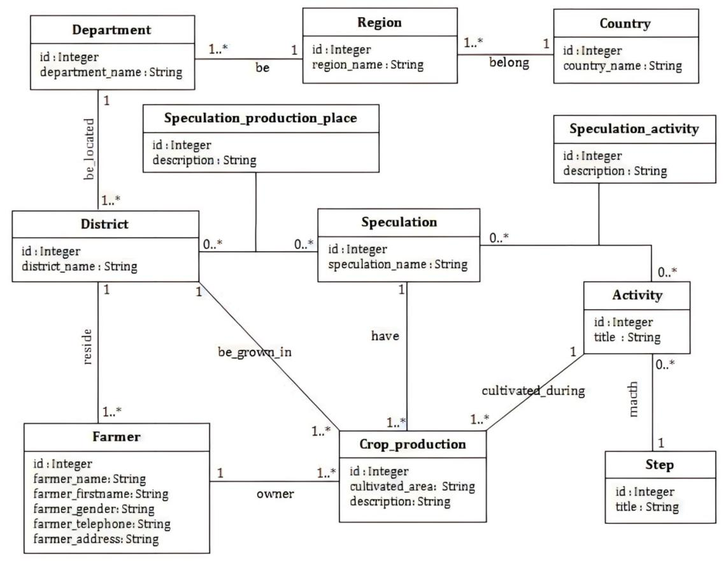

4.22

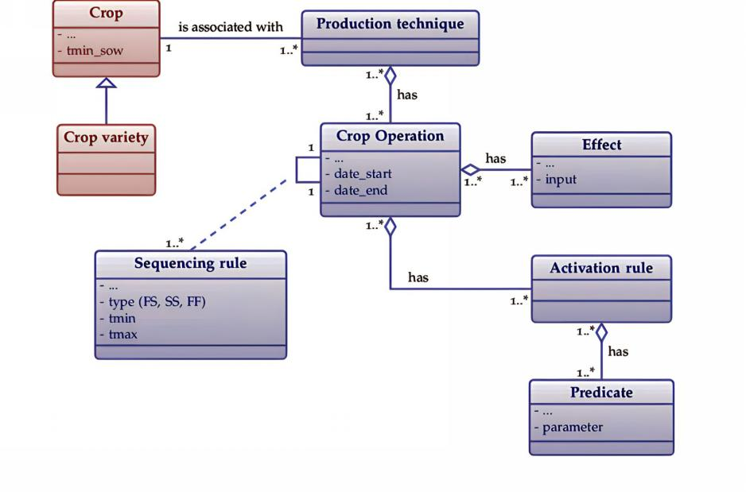

**4.3 Interaction diagrams**

4.31 -Sequence diagram

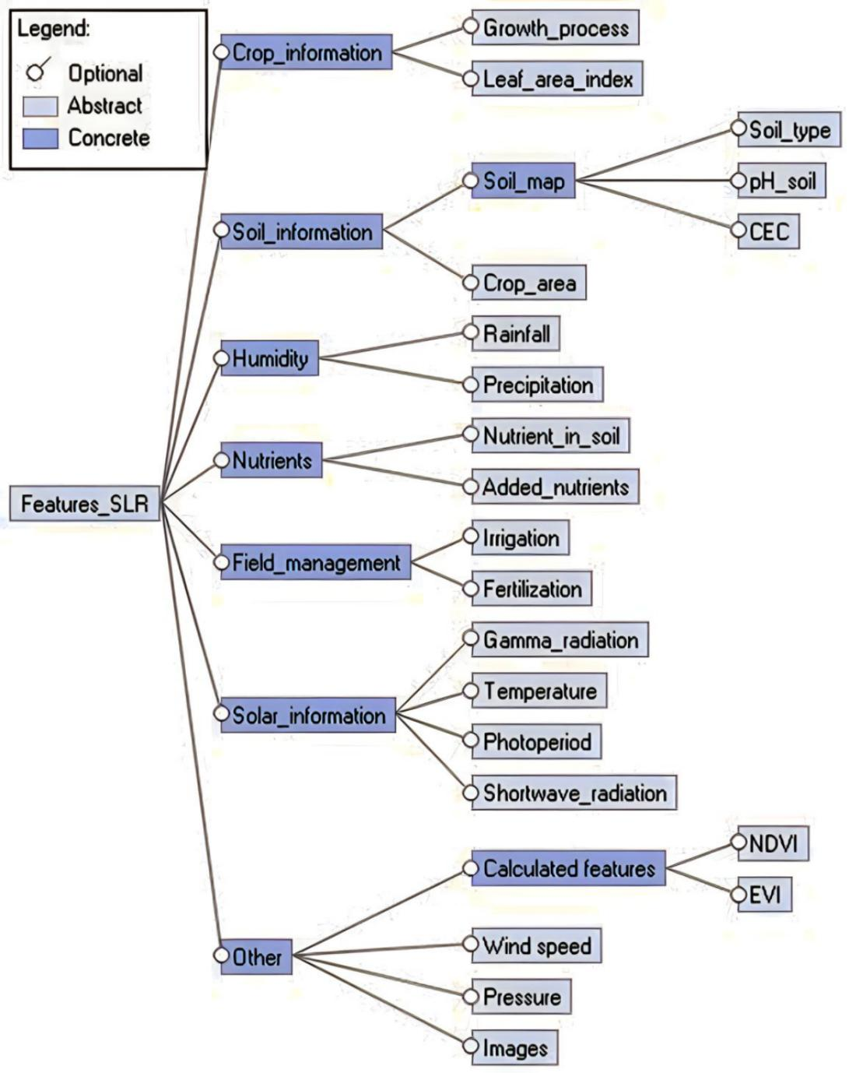

4.32 -Collaboration diagram

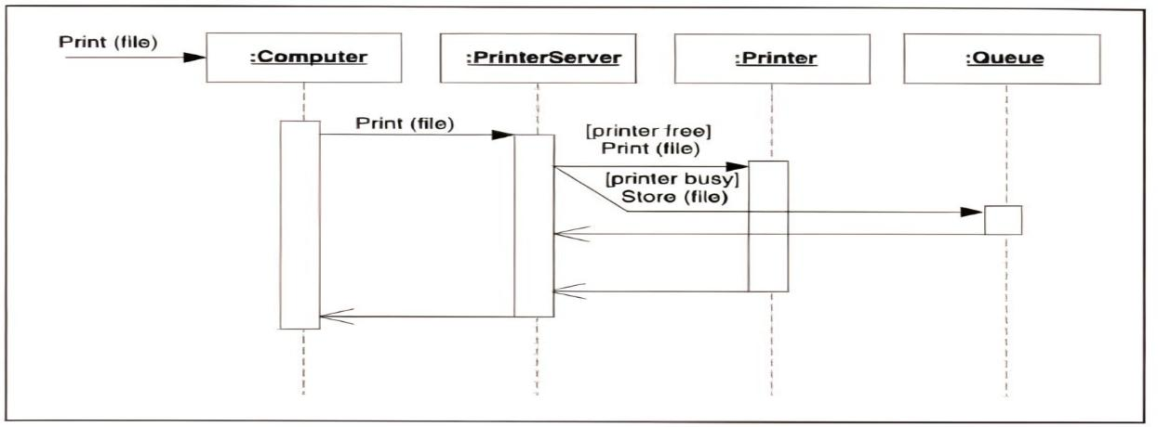

**4.4 Activity Diagram:**

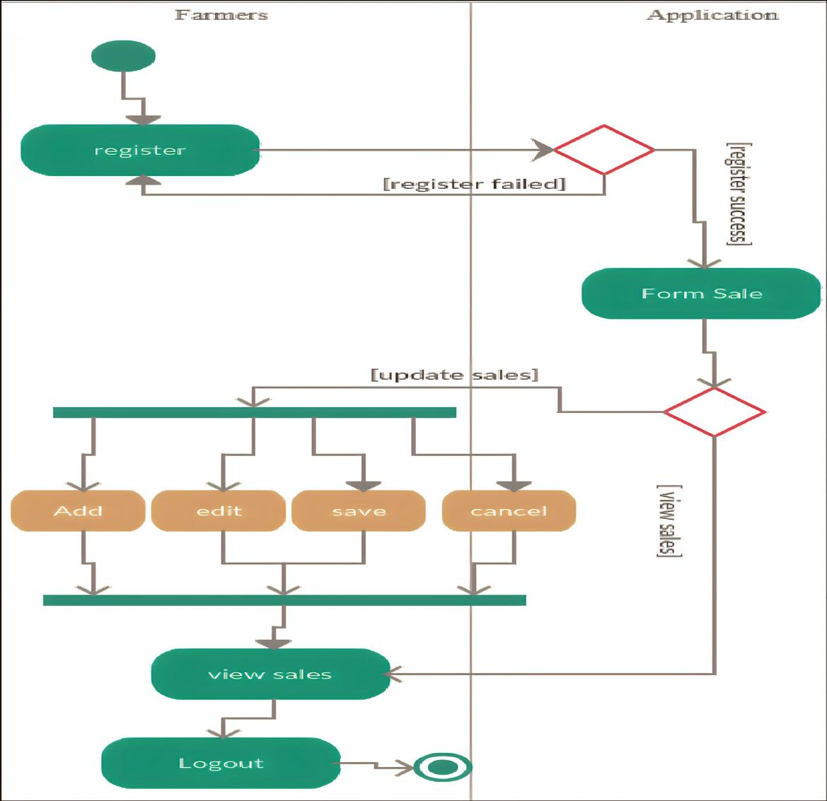

**4.5 Database Design**

4.51 -E-R Diagrams

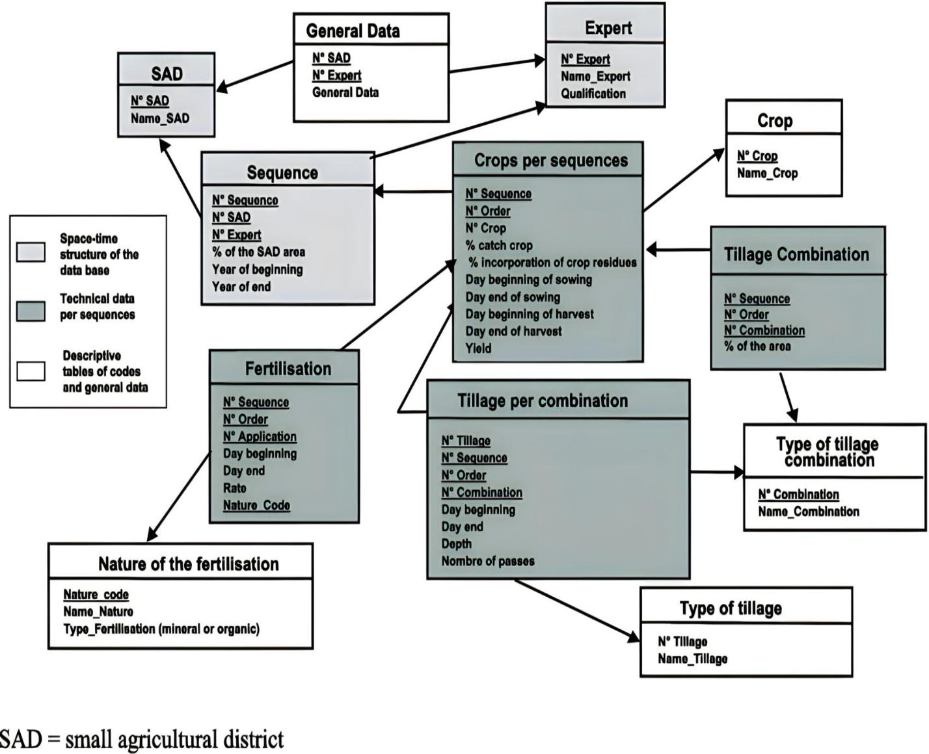

**CHAPTER 5**

**CODING / CODE TEMPLATES**

**Home:**

<!doctype html>

<html lang="en">

<head>

<meta charset="utf-8">

<meta name="viewport" content="width=device-width, initial-scale=1">

<title>Smart AgroTech</title>

<link rel="stylesheet" href="https://cdn.jsdelivr.net/npm/bootstrap@5.3.0-alpha1/dist/css/bootstrap.min.css"

integrity="sha384-GLhlTQ8iRABdZLl6O3oVMWSktQOp6b7In1Zl3/Jr59b6EGGoI1aFkw7cmDA6j6gD" crossorigin="anonymous">

<link href="footer.css" rel="stylesheet">

</head>

<body>

<div class="container">

<nav class="navbar navbar-expand-lg fixed-top navbar-dark bg-dark">

<div class="container-fluid">

<a class="navbar-brand" href="#">Smart AgroTech</a>

<button class="navbar-toggler" type="button" data-bs-toggle="collapse"

data-bs-target="#navbarNavDropdown" aria-controls="navbarNavDropdown" aria-expanded="false"

aria-label="Toggle navigation">

<span class="navbar-toggler-icon"></span>

</button>

<div class="collapse navbar-collapse" id="navbarNavDropdown">

<ul class="navbar-nav">

<li class="nav-item">

<a class="nav-link active" href="home.html"><img src="home.gif" alt="" width="17"

height="14">Home</a>

</li>

<li class="nav-item">

<a class="nav-link" href="about.html"><img src="about.gif" alt="" width="17"

height="14">About Us</a>

</li>

<li class="nav-item">

<a class="nav-link" href="#govt_schemes"><img src="scheme.gif" alt="" width="17"

height="14">Govt Schemes</a>

</li>

<li class="nav-item">

<a class="nav-link" href="contact.html"><img src="contact.gif" alt="" width="17"

height="14">Contact Us</a>

</li>

<li class="nav-item">

<a class="nav-link" href="gallery.html"><img src="gallery.gif" alt="" width="17"

height="14">Gallery</a>

</li>

<li class="nav-item">

<a class="nav-link" href="team.html"><img src="team.gif" alt="" width="16"

height="14">Team</a>

</li>

<div class="dropdown" data-bs-theme="dark">

<li class="nav-item dropdown">

<a class="nav-link dropdown-toggle" href="#" id="navbarDropdownMenuLink" role="button"

data-bs-toggle="dropdown" aria-expanded="false">

More <img src="more.gif" alt="" width="16" height="15">

</a>

<ul class="dropdown-menu" aria-labelledby="navbarDropdownMenuLinkButtonDark">

<li><a class="dropdown-item" href="precision.html">Precision-Farm</a></li>

<li><a class="dropdown-item" href="Automated.html">Automated-Machinery</a></li>

<li><a class="dropdown-item" href="Vertical.html">Vertical-Farming</a></li>

<li><a class="dropdown-item" href="crop_management.html">Crop-Management</a></li>

<li><a class="dropdown-item" href="livestock.html">LiveStock-Monitoring</a></li>

</ul>

</li>

</div>

</ul>

</div>

</div>

</nav><br><br>

<div class="jumbotron jumbotron-fluid">

<div class="container my-4">

<h1 class="display-4"><strong>Smart AgroTech</strong></h1>

<p class="dark">Welcome to SMART AGROTECH, We are dedicated to provide the information of sustainable

and efficient

agricultural practices through the use of innovative technologies to the farmers worldwide.</p>

</div>

</div>

<div class="alert alert-warning alert-dismissible fade show my-4" role="alert">

<strong>It's our Promise! </strong> Here you'll learn most of Smart Agriculture Technology.

<button type="button" class="btn-close" data-bs-dismiss="alert" aria-label="Close"></button>

</div><br>

<div class="container-md my-4">

<div id="carouselExampleFade" class="carousel slide carousel-fade" data-bs-ride="carousel">

<div class="carousel-inner">

<div class="carousel-item active">

<img src="pf2.jpg" class="img-fluid d-block w-100 h-100" alt="...">

</div>

<div class="carousel-item">

<img src="cm.jpg" class=" img-fluid d-block w-100 h-100" alt="...">

</div>

<div class="carousel-item">

<img src="iot.jpg" class="img-fluid d-block w-100 h-100" alt="...">

</div>

</div>

<button class="carousel-control-prev" type="button" data-bs-target="#carouselExampleFade"

data-bs-slide="prev">

<span class="carousel-control-prev-icon" aria-hidden="true"></span>

<span class="visually-hidden">Previous</span>

</button>

<button class="carousel-control-next" type="button" data-bs-target="#carouselExampleFade"

data-bs-slide="next">

<span class="carousel-control-next-icon" aria-hidden="true"></span>

<span class="visually-hidden">Next</span>

</button>

</div>

</div>

<div class="d-flex justify-content-center">

<div class="card mx-auto" style="width: 48rem;">

<img src="smm.jpg" class="card-img-top" alt="...">

<div class="card-body">

<h5 class="card-title">Smart Agriculture Technology</h5>

<p class="card-text">Smart agriculture technology is a system that utilizes various technologies

such

as Internet of Things (IoT), big data analytics, artificial intelligence, and drones to improve

efficiency

and productivity in agriculture. These technologies can help farmers optimize their crop yields,

reduce

waste, conserve resources, and improve food quality. Smart agriculture systems may include

sensors

to

monitor soil moisture and nutrient levels, drones to map fields and assess crop health, and

automated

irrigation systems to deliver water precisely where and when it is needed. Overall, smart

agriculture

technology aims to create a more sustainable and productive agriculture industry.</p>

</div>

</div>

</div>

<div class="row row-cols-1 row-cols-md-2 g-4 my-4">

<div class="col">

<div class="card h-100">

<img src="am.1.jpg" class="card-img-top" alt="">

<div class="card-body">

<h3 class="card-title bg-success"><strong>Precesion Farming</strong></h3>

<p class="card-text">Precision farming, also known as precision agriculture, is an approach to

farming that uses technology to optimize crop production and reduce waste. It involves the

use of advanced technologies such as GPS, sensors, and mapping tools to monitor and analyze

crop growth, soil conditions, and weather patterns.<br><br>By gathering detailed information

about the farm's soil, climate, and crops, precision farming enables farmers to make

informed decisions about fertilizers, irrigation, planting, and harvesting. This allows them

to apply the right amount of inputs at the right time and in the right location, thereby

maximizing yields and minimizing waste. It can also help farmers decrease their

environmental impact by reducing the use of chemical compound and water, and reducing soil

erosion.</p>

<a href="precision.html" class="btn btn-secondary">Continue reading...</a>

<hr>

<hr>

<p>Here are some SOFTWARES on PRECISION FARMING: </p>

<div class="card" style="width: 18rem;">

<ul class="list-group list-group-flush">

<li class="list-group-item"><a class="btn btn-primary" target="_blank"

href=" https://www.agworld.com/" role="button">AgWorld</a></li>

<li class="list-group-item"><a class="btn btn-success" target="_blank"

href=" https://granular.ag/" role="button">Granular</a></li>

<li class="list-group-item"><a class="btn btn-secondary" target="_blank"

href=" https://www.agrisight.com/" role="button">AgriSight</a></li>

<li class="list-group-item"><a class="btn btn-info" target="_blank"

href="https://climate.com/" role="button">Climate FieldView</a></li>

<li class="list-group-item"><a class="btn btn-dark" target="_blank"

href="https://agriculture.trimble.com/en" role="button">Trimble Ag Software</a>

</li>

</ul>

</div>

</div>

<hr>

</div>

</div>

<div class="col">

<div class="card h-100">

<img src="a-m.jpg" class="card-img-top" alt="...">

<div class="card-body">

<h3 class="card-title bg-success"><strong>Automated Machinery</strong></h3>

<p class="card-text">Farm automation, often associated with “smart farming”, is technology that

makes farms more efficient and automates the crop or livestock production cycle. An

increasing number of companies are working on robotics innovation to develop drones,

autonomous tractors, robotic harvesters, automatic watering, and seeding robots. Although

these technologies are fairly new, the industry has seen an increasing number of traditional

agriculture companies adopt farm automation into their processes.<br><br>Smart farming can

also involve the use of automated machinery, such as tractors and harvesters, that use GPS

and other technologies to optimize farming operations. This can improve efficiency and

reduce labor costs.</p>

<a href="Automated.html" class="btn btn-secondary">Continue reading...</a>

<hr>

<hr>

<p>Here are some SOFTWARES on AUTOMATED MACHINERY: </p>

<div class="card" style="width: 18rem;">

<ul class="list-group list-group-flush">

<li class="list-group-item"><a class="btn btn-primary" target="_blank"

href=" https://portal.ravenslingshot.com/" role="button">Raven Slingshot</a>

</li>

<li class="list-group-item"><a class="btn btn-success" target="_blank"

href="https://www.agcotechnologies.com/en/AgCommand/" role="button">AGCO

AgCommand</a>

</li>

<li class="list-group-item"><a class="btn btn-secondary" target="_blank"

href="https://agriculture.trimble.com/software/" role="button">Trimble Ag

Software</a>

</li>

<li class="list-group-item"><a class="btn btn-info" target="_blank"

href="https://www.caseih.com/northamerica/en-us/products/afs-connect"

role="button">Case IH AFS Connect</a>

</li>

<li class="list-group-item"><a class="btn btn-dark" target="_blank"

href="https://www.deere.com/en/technology-products/ag-management-solutions/operations-center/"

role="button">John Deere Operations Center</a>

</li>

</ul>

</div>

</div>

<hr>

</div>

</div>

<div class="col">

<div class="card h-100">

<img src="vf.1.jpg" class="card-img-top" alt="...">

<div class="card-body">

<h3 class="card-title bg-success"><strong>Vertical Farming</strong></h3>

<p class="card-text">Vertical farming involves growing crops in stacked layers, using artificial

lighting and controlled environments to optimize growth. Smart farming technologies can be

used to monitor and control environmental factors like temperature, humidity, and lighting,

to maximize crop yields.<br><br>It often incorporates controlled-environment agriculture,

which aims to optimize plant growth, and soilless farming techniques such as hydroponics,

aquaponics, and aeroponics.</p>

<a href="Vertical.html" class="btn btn-secondary">Continue reading...</a>

<hr>

<hr>

<p>Here are some SOFTWARES on VERTICAL FARMING: </p>

<div class="card" style="width: 18rem;">

<ul class="list-group list-group-flush">

<li class="list-group-item"><a class="btn btn-primary" target="_blank"

href="https://gro.io/" role="button">Gro.io</a></li>

<li class="list-group-item"><a class="btn btn-success" target="_blank"

href="https://www.agrilyst.com/" role="button">Agrilyst</a></li>

<li class="list-group-item"><a class="btn btn-secondary" target="_blank"

href="https://growlink.com/" role="button">Growlink</a>

</li>

<li class="list-group-item"><a class="btn btn-info" target="_blank"

href="https://cropzilla.com/" role="button">CropZilla</a></li>

<li class="list-group-item"><a class="btn btn-dark" target="_blank"

href="https://www.vertifarm.com/" role="button">VertiFarm</a></li>

</ul>

</div>

</div>

<hr>

</div>

</div>

<div class="col">

<div class="card h-100">

<img src="c-m.jpg" class="card-img-top" alt="...">

<div class="card-body">

<br><br>

<h3 class="card-title bg-success"><strong>Crop Management</strong></h3>

<p class="card-text">Crop management technology includes irrigation systems, crop monitoring

systems, and

plant nutrition management systems, which help farmers to optimize crop growth and

maximize

yields.<br><br>Crop management software is a type of smart farming technology that helps

farmers

to manage and optimize their crop production. Some of the features of crop management

software

include: Harvest Planning, Weather Monitoring, Record-Keeping...

</p><br>

<a href="crop_management.html" class="btn btn-secondary">Continue reading...</a>

<hr>

<hr>

<p>Here are some SOFTWARES on CROP MANAGEMENT: </p>

<div class="card" style="width: 18rem;">

<ul class="list-group list-group-flush">

<li class="list-group-item"><a class="btn btn-primary" target="_blank"

href="https://cropio.com/" role="button">Cropio</a></li>

<li class="list-group-item"><a class="btn btn-success" target="_blank"

href="https://www.agworld.com/" role="button">Agworld</a></li>

<li class="list-group-item"><a class="btn btn-secondary" target="_blank"

href="https://granular.ag/" role="button">Granular</a></li>

<li class="list-group-item"><a class="btn btn-info" target="_blank"

href="https://farmlogs.com/" role="button">FarmLogs</a></li>

<li class="list-group-item"><a class="btn btn-dark" target="_blank"

href="https://agriculture.trimble.com/software/" role="button">Trimble Ag

Softwar</a></li>

</ul>

</div>

</div>

<hr>

</div>

</div>

</div>

<div class="d-flex justify-content-center">

<div class="card mx-auto" style="width: 48rem;">

<img src="live1.jpg" class="card-img-top" alt="...">

<div class="card-body">

<h3 class="card-title bg-success"><strong>Livestock Monitoring</strong></h3>

<p class="card-text">"Livestock monitoring is a type of smart farming technology that involves

using

sensors

and other advanced technologies to monitor the health and behavior of livestock, such as

monitoring

vital signs and movement patterns. This technology can help farmers detect and address

potential

health issues early, reduce the risk of disease outbreaks, and improve animal

welfare.<br><br>Some

common types of livestock monitoring technology include: Wearable Sensors, GPS Tracking,

Camera

Monitoring, Automated Feeders, Heat Detection.</p>

<a href="livestock.html" class="btn btn-secondary ">Continue reading...</a>

<hr>

<hr>

<p>Here are some SOFTWARES on LIVESTOCK MONITORING: </p>

<div class="card" style="width: 18rem;">

<ul class="list-group list-group-flush">

<li class="list-group-item"><a class="btn btn-primary" target="_blank"

href="https://www.afimilk.com/" role="button">Afimilk</a>

</li>

<li class="list-group-item"><a class="btn btn-success" target="_blank"

href="https://www.cainthus.com/" role="button">Cainthus</a>

</li>

<li class="list-group-item"><a class="btn btn-secondary" target="_blank"

href="https://www.scrdairy.com/" role="button">SCR Dairy</a>

</li>

<li class="list-group-item"><a class="btn btn-info" target="_blank"

href="https://connecterra.io/" role="button">Connecterra</a>

</li>

<li class="list-group-item"><a class="btn btn-dark" target="_blank"

href="https://www.allflex.global/" role="button">Allflex Livestock Intelligence</a>

</li>

</ul>

</div>

</div>

<hr>

</div>

</div>

<div class="container my-4">

<button type="button" class="btn btn-primary" data-bs-toggle="modal" data-bs-target="#staticBackdrop">

Click to see quote

</button>

<div class="modal fade" id="staticBackdrop" data-bs-backdrop="static" data-bs-keyboard="false" tabindex="-1"

aria-labelledby="staticBackdropLabel" aria-hidden="true">

<div class="modal-dialog modal-dialog-centered">

<div class="modal-content">

<div class="modal-header">

<h1 class="modal-title fs-5" id="staticBackdropLabel">Farm_quote</h1>

<button type="button" class="btn-close" data-bs-dismiss="modal" aria-label="Close"></button>

</div>

<div class="modal-body">

"The smartest farmers are those who embrace technology and use it to their

advantage,<br> -

to create a more efficient and sustainable farming system that benefits everyone".

</div>

<div class="modal-footer">

<button type="button" class="btn btn-secondary" data-bs-dismiss="modal">Close</button>

</div>

</div>

</div>

</div>

</div>

<div class="container">

<div class="card my-4">

<div class="card-header">

Quotes

</div>

<div class="card-body">

<h5 class="card-title">Special quotes on Smart Farming</h5>

<p class="card-text">-=]> "The agriculture industry is the backbone of the economy and

technology is

the

key to its success".

<br><br> -=]> "The ultimate goal of farming is not the growing of crops, but the cultivation

and

perfection of human beings".

<br><br> -=]> "Agriculture is not about creating a perfect ecosystem, but about balancing

the

natural and the technological worlds".

<br><br> -=]> "Smart agriculture is not just about technology, it's about the integration of

technology and sustainability".

<br><br> -=]> "The future of agriculture is not about better tractors or bigger

combines,<br> -

it's about

advanced analytics, data-driven decision making, and automation".

<br><br> -=]> "The smartest farmers are those who embrace technology and use it to their

advantage,<br> -

to create a more efficient and sustainable farming system that benefits everyone".

<br><br> -=]> "Smart agriculture is not just about technology, <br> it's about combining the

best of

human expertise with the power of machines to create a more sustainable, productive, and

profitable

farming system".

<br><br> -=]> "The discovery of Agriculture was the first big step toward a civilized life".

<br><br> -=]> "From seed to harvest, let technology lead the way to a brighter future".

<br><br> -=]> "Farming smarter, not harder".

<br><br> -=]> "Digitizing agriculture for a brighter tomorrow".

<br><br> -=]> "Smart agriculture: the key to feeding the world's growing population".

</p>

</div>

</div>

</div><br><br>

<div id="govt_schemes" class="container-fluid">

<br><br><br><div class="card">

<h2 class="card-header text-center">Government Schemes for Farmers</h2>

<div class="card-body">

<h5 class="card-title">Pradhan Mantri Fasal Bima Yojana (PMFBY): </h5>

<p class="card-text">This scheme provides crop insurance to farmers in case of crop failure due to

natural calamities, pests, and diseases.</p>

<a href=" https://pmfby.gov.in/" class="btn btn-secondary">Go to PMFBY site..</a>

</div>

<div class="card-body">

<h5 class="card-title">Pradhan Mantri Kisan Samman Nidhi (PM-KISAN): </h5>

<p class="card-text">This is a direct income support scheme for farmers, under which

Rs. 6,000 per year is provided to eligible farmers in three installments.</p>

<a href="https://pmkisan.gov.in/" class="btn btn-secondary">Go to PM-KISAN site..</a>

</div>

<div class="card-body">

<h5 class="card-title">Rashtriya Krishi Vikas Yojana (RKVY): </h5>

<p class="card-text">This scheme provides financial assistance to states for promoting

agriculture and allied activities, such as horticulture, livestock, fisheries, and

agro-processing.

</p>

<a href="https://rkvy.nic.in/" class="btn btn-secondary">Go to RKVY site..</a>

</div>

<div class="card-body">

<h5 class="card-title">National Food Security Mission (NFSM): </h5>

<p class="card-text">This scheme aims to increase the production and productivity of rice,

wheat, and pulses through the adoption of improved technologies.</p>

<a href="https://nfsm.gov.in/" class="btn btn-secondary">Go to NFSM site..</a>

</div>

<div class="card-body">

<h5 class="card-title">Soil Health Card Scheme: </h5>

<p class="card-text">This scheme aims to promote soil testing and provide farmers with customized

recommendations to improve soil health and productivity.</p>

<a href="https://soilhealth.dac.gov.in/" class="btn btn-secondary">Go to SHCS site..</a>

</div>

<div class="card-body">

<h5 class="card-title">Pradhan Mantri Krishi Sinchai Yojana (PMKSY): </h5>

<p class="card-text">This scheme aims to provide irrigation facilities to farmers and

increase water use efficiency.</p>

<a href="https://pmksy.gov.in/" class="btn btn-secondary">Go to PMKSY site..</a>

</div>

<div class="card-body">

<h5 class="card-title">National Agriculture Market (e-NAM):</h5>

<p class="card-text">This scheme aims to create a unified national market for agricultural

commodities and connect farmers with buyers across the country.</p>

<a href="https://www.enam.gov.in/web/" class="btn btn-secondary">Go to e-NAM site..</a>

</div>

<div class="card-body">

<h5 class="card-title">Interest Subvention Scheme for Agriculture: </h5>

<p class="card-text">This scheme provides interest subvention to farmers on short-term

crop loans, which helps reduce their cost of borrowing.</p>

<a href="https://www.nabard.org/content.aspx?id=553" class="btn btn-secondary">Go to ISSfA

site..</a>

</div>

</div>

</div><br>

<a href="home.html" class="btn btn-dark">Go To Top..</a>

<hr>

</div>

<div class="container my-4">

<footer>

<div class="social-links">

<ul class="list-inline social-icons">

<li><a href="#"><img src="facebook.gif" alt="Facebook"></a></li>

<li><a href="https://www.instagram.com/invites/contact/?i=htj333d872zd&utm_content=3d7lkwu"

target="_blank"><img src="instagram.gif" alt="Instagram"></a></li>

<li><a href="https://whatsapp.com/dl/" target="_blank"><img src="whatsapp.gif" alt="Whatsapp"></a>

</li>

<li><a href="#"><img src="twitter.gif" alt="Twitter"></a></li><br><br>

<span class="mb-3 mb-md-0 text-body-secondary">© 2023 Company, Inc</span>

</ul>

</div>

</footer>

</div>

<script src="https://cdn.jsdelivr.net/npm/bootstrap@5.3.0-alpha2/dist/js/bootstrap.bundle.min.js"></script>

</body>

</html>

**About Us:**

<!DOCTYPE html>

<html lang="en">

<head>

<meta charset="UTF-8">

<meta http-equiv="X-UA-Compatible" content="IE=edge">

<meta name="viewport" content="width=device-width, initial-scale=1.0">

<title>About us</title>

<link href="https://cdn.jsdelivr.net/npm/bootstrap@5.3.0-alpha1/dist/css/bootstrap.min.css" rel="stylesheet"

integrity="sha384-GLhlTQ8iRABdZLl6O3oVMWSktQOp6b7In1Zl3/Jr59b6EGGoI1aFkw7cmDA6j6gD" crossorigin="anonymous">

<link href="footer.css" rel="stylesheet">

</head>

<body>

<div class="container">

<nav class="navbar navbar-expand-lg fixed-top navbar-dark bg-dark">

<div class="container-fluid">

<a class="navbar-brand" href="#">Smart AgroTech</a>

<button class="navbar-toggler" type="button" data-bs-toggle="collapse"

data-bs-target="#navbarNavDropdown" aria-controls="navbarNavDropdown" aria-expanded="false"

aria-label="Toggle navigation">

<span class="navbar-toggler-icon"></span>

</button>

<div class="collapse navbar-collapse" id="navbarNavDropdown">

<ul class="navbar-nav">

<li class="nav-item">

<a class="nav-link" href="home.html"><img src="home.gif" alt="" width="17"

height="14">Home</a>

</li>

<li class="nav-item">

<a class="nav-link active" href="about.html"><img src="about.gif" alt="" width="17"

height="14">About Us</a>

</li>

<li class="nav-item">

<a class="nav-link" href="contact.html"><img src="contact.gif" alt="" width="17"

height="14">Contact Us</a>

</li>

<li class="nav-item">

<a class="nav-link" href="gallery.html"><img src="gallery.gif" alt="" width="17"

height="14">Gallery</a>

</li>

<li class="nav-item">

<a class="nav-link" href="team.html"><img src="team.gif" alt="" width="16"

height="14">Team</a>

</li>

<div class="dropdown" data-bs-theme="dark">

<li class="nav-item dropdown">

<a class="nav-link dropdown-toggle" href="#" id="navbarDropdownMenuLink" role="button"

data-bs-toggle="dropdown" aria-expanded="false">

More <img src="more.gif" alt="" width="16" height="15">

</a>

<ul class="dropdown-menu" aria-labelledby="navbarDropdownMenuLinkButtonDark">

<li><a class="dropdown-item" href="precision.html">Precision-Farm</a></li>

<li><a class="dropdown-item" href="Automated.html">Automated-Machinery</a></li>

<li><a class="dropdown-item" href="Vertical.html">Vertical-Farming</a></li>

<li><a class="dropdown-item" href="crop_management.html">Crop-Management</a></li>

<li><a class="dropdown-item" href="livestock.html">LiveStock-Monitoring</a></li>

</ul>

</li>

</div>

</ul>

</div>

</div>

</nav>

<br><br>

<div class="container my-4">

<div class="text-center">

<img src="about1.jpg" class="rounded img-fluid" alt="...">

</div>

</div>

<section class="py-5 text-center container">

<div class="row py-lg-5">

<div class="col-lg-6 col-md-8 mx-auto">

<p class="lead text-bg-secondary">

Welcome to Smart AgroTech. Our website is dedicated to promoting sustainable and efficient

agricultural practices through the use of innovative technologies.At Smart AgroTech, we believe

that

technology can play a crucial role in addressing some of the most pressing challenges facing the

agriculture industry today. By leveragings cutting-edge technologies like IoT, big data

analytics,

and

artificial intelligence, farmers and agribusinesses can optimize their operations, reduce waste,

and

increase

yields while minimizing their environmental impact.Our team members are passionate about

smart agriculture and are committed to sharing our knowledge with farmers. We strive to

provide high-quality, accurate, and up-to-date information on the latest trends and innovations

in

the

field.<br><br>We are committed to promoting innovation and collaboration in the agriculture

industry,

and to driving positive change that benefits farmers, consumers, and the planet.We are

passionate

about exploring new technologies, to build a more sustainable and

resilient agriculture system.</p>

</div>

</div>

</section>

<div class="container">

<div class="row row-cols-1 row-cols-md-2 g-4">

<div class="col">

<div class="card">

<div class="card-body">

<h5 class="card-title">Mission</h5>

<p class="card-text">Our mission is to empower farmers and agribusinesses around the world

with

the

knowledge and

tools they need to adopt sustainable and profitable farming practices.</p>

</div>

</div>

</div>

<div class="col">

<div class="card">

<div class="card-body">

<h5 class="card-title">Belief</h5>

<p class="card-text">We believe that Smart Agriculture Technology has the potential to

revolutionize the way we

grow and produce food.</p>

</div>

</div>

</div>

<div class="col">

<div class="card">

<div class="card-body">

<h5 class="card-title">Highlight</h5>

<p class="card-text">We will also share up-to-date information about farmers regarding

Government Schemes.</p>

</div>

</div>

</div>

<div class="col">

<div class="card">

<div class="card-body">

<h5 class="card-title">Trend</h5>

<p class="card-text">Internet of Things (IoT), Artificial Intelligence (AI),

Robotics,<br>

Blockchain</p>

</div>

</div>

</div>

</div>

</div>

<section class="py-5 text-center container">

<div class="card mb-3 my-4" style="max-width: 740px;">

<div class="row g-0">

<div class="col-md-4">

<img src="join.jpg" class="img-fluid rounded-start" alt="...">

</div>

<div class="col-md-8">

<div class="card-body">

<h5 class="card-title">"Join us in Building a Sustainable and Food-Secure Future with Smart

Agriculture Technology"</h5>

<p class="card-text">Thank you for taking the time to learn more about Smart AgroTech and

our

mission to

promote smart

agriculture technology. We are dedicated to providing high-quality, accurate, and

up-to-date

information on the latest developments and trends in the field, and to helping farmers

and

agribusinesses adopt sustainable and efficient farming practices.<br><br>Thank you again

for

visiting Smart AgroTech. We look forward to continuing to serve as your trusted source

for

information and insights on smart agriculture technology.</p>

</div>

</div>

</div>

</div>

</section>

<div class="container">

<div>

<h4 style="text-align: center;">Development</h4>

<div class="progress" role="progressbar" aria-label="Success striped example" aria-valuenow="25"

aria-valuemin="0" aria-valuemax="100">

<div class="progress-bar progress-bar-striped bg-success" style="width: 90%"></div>

</div>

<h4 style="text-align: center;">Design</h4>

<div class="progress" role="progressbar" aria-label="Info striped example" aria-valuenow="50"

aria-valuemin="0" aria-valuemax="100">

<div class="progress-bar progress-bar-striped bg-info" style="width: 80%"></div>

</div>

<h4 style="text-align: center;">Advertising</h4>

<div class="progress" role="progressbar" aria-label="Warning striped example" aria-valuenow="75"

aria-valuemin="0" aria-valuemax="100">

<div class="progress-bar progress-bar-striped bg-warning" style="width: 70%"></div>

</div>

<h4 style="text-align: center;">Dedication</h4>

<div class="progress" role="progressbar" aria-label="Danger striped example" aria-valuenow="100"

aria-valuemin="0" aria-valuemax="100">

<div class="progress-bar progress-bar-striped bg-danger" style="width: 100%"></div>

</div>

</div><br>

<a href="about.html" class="btn btn-secondary">Go to Top..</a>

</div><br><br>

<hr>

</div>

<div class="container my-4">

<footer>

<div class="social-links">

<ul class="list-inline social-icons">

<li><a href="#"><img src="facebook.gif" alt="Facebook"></a></li>

<li><a href="https://www.instagram.com/invites/contact/?i=htj333d872zd&utm_content=3d7lkwu"

target="_blank"><img src="instagram.gif" alt="Instagram"></a></li>

<li><a href="https://whatsapp.com/dl/" target="_blank"><img src="whatsapp.gif" alt="Whatsapp"></a></li>

<li><a href="#"><img src="twitter.gif" alt="Twitter"></a></li><br><br>

<span class="mb-3 mb-md-0 text-body-secondary">© 2023 Company, Inc</span>

</ul>

</div>

</footer>

</div>

<script src="https://cdn.jsdelivr.net/npm/bootstrap@5.3.0-alpha2/dist/js/bootstrap.bundle.min.js"></script>

</body>

</html>

**Team:**

<!DOCTYPE html>

<html lang="en">

<head>

<meta charset="UTF-8">

<meta http-equiv="X-UA-Compatible" content="IE=edge">

<meta name="viewport" content="width=device-width, initial-scale=1.0">

<title>Team</title>

<link href="https://cdn.jsdelivr.net/npm/bootstrap@5.3.0-alpha1/dist/css/bootstrap.min.css" rel="stylesheet"

integrity="sha384-GLhlTQ8iRABdZLl6O3oVMWSktQOp6b7In1Zl3/Jr59b6EGGoI1aFkw7cmDA6j6gD" crossorigin="anonymous">

<link href="footer.css" rel="stylesheet">

</head>

<body>

<div class="container">

<nav class="navbar navbar-expand-lg fixed-top navbar-dark bg-dark">

<div class="container-fluid">

<a class="navbar-brand" href="#">Smart AgroTech</a>

<button class="navbar-toggler" type="button" data-bs-toggle="collapse"

data-bs-target="#navbarNavDropdown" aria-controls="navbarNavDropdown" aria-expanded="false"

aria-label="Toggle navigation">

<span class="navbar-toggler-icon"></span>

</button>

<div class="collapse navbar-collapse" id="navbarNavDropdown">

<ul class="navbar-nav">

<li class="nav-item">

<a class="nav-link" href="home.html"><img src="home.gif" alt="" width="17"

height="14">Home</a>

</li>

<li class="nav-item">

<a class="nav-link" href="about.html"><img src="about.gif" alt="" width="17"

height="14">About Us</a>

</li>

<li class="nav-item">

<a class="nav-link" href="contact.html"><img src="contact.gif" alt="" width="17"

height="14">Contact Us</a>

</li>

<li class="nav-item">

<a class="nav-link" href="gallery.html"><img src="gallery.gif" alt="" width="17"

height="14">Gallery</a>

</li>

<li class="nav-item">

<a class="nav-link active" href="team.html"><img src="team.gif" alt="" width="16"

height="14">Team</a>

</li>

<div class="dropdown" data-bs-theme="dark">

<li class="nav-item dropdown">

<a class="nav-link dropdown-toggle" href="#" id="navbarDropdownMenuLink" role="button"

data-bs-toggle="dropdown" aria-expanded="false">

More <img src="more.gif" alt="" width="16" height="15">

</a>

<ul class="dropdown-menu" aria-labelledby="navbarDropdownMenuLinkButtonDark">

<li><a class="dropdown-item" href="precision.html">Precision-Farm</a></li>

<li><a class="dropdown-item" href="Automated.html">Automated-Machinery</a></li>

<li><a class="dropdown-item" href="Vertical.html">Vertical-Farming</a></li>

<li><a class="dropdown-item" href="crop_management.html">Crop-Management</a></li>

<li><a class="dropdown-item" href="livestock.html">LiveStock-Monitoring</a></li>

</ul>

</li>

</div>

</ul>

</div>

</div>

</nav>

<br><br>

<div class="container my-4 fixed-medium">

<button type="button" class="btn btn-primary" data-bs-toggle="modal" data-bs-target="#staticBackdrop">

Click to see quote

</button>

<div class="modal fade" id="staticBackdrop" data-bs-backdrop="static" data-bs-keyboard="false" tabindex="-1"

aria-labelledby="staticBackdropLabel" aria-hidden="true">

<div class="modal-dialog modal-dialog-centered">

<div class="modal-content">

<div class="modal-header">

<h1 class="modal-title fs-5" id="staticBackdropLabel">Farm_quote</h1>

<button type="button" class="btn-close" data-bs-dismiss="modal" aria-label="Close"></button>

</div>

<div class="modal-body">

"From seed to harvest, let technology lead the way to a brighter future".

</div>

<div class="modal-footer">

<button type="button" class="btn btn-secondary" data-bs-dismiss="modal">Close</button>

</div>

</div>

</div>

</div>

</div>

<div class="d-flex justify-content-center">

<div class="card mx-auto" style="width: 48rem;">

<img src="team1.jpg" class="card-img-top img-fluid" alt="...">

<div class="card-body">

<p class="card-text">At Smart AgroTech, we are a team of dedicated mates who are committed to

advancing

the agriculture industry

through innovation and collaboration. We are passionate about smart agriculture technology and

the

positive

impact it can have on farmers, farm-quotes, and the planet. If you have any questions or

feedback,

please

don't

hesitate to get in touch with us. We would love to hear from you! </p>

<a href="contact.html" class="btn btn-primary ">Go to Contact </a>

</div>

</div>

</div>

<div class="container">

<div class="card text-bg-secondary mb-3 my-4" style="max-width: 28rem;">

<h3 class="card-header">Gaddam Karthik Reddy</h3>

<div class="card-body">

<h5 class="card-title"><ins>Front End and Back End Developer</ins></h5>

<p class="card-text">Front-End Developer and Multimedia Creator, Back End Developer with knowledge

in MongoDB, NodeJS ,Able front-end developer with

knowledge

in HTML, CSS, Bootstrap and

JavaScript.Responsible for creating the website's visually attractive design and achieving

interactive looks that build up the user experience.</p>

</div>

</div>

<div class="d-flex justify-content-center">

<div class="card mx-auto text-bg-success mb-3" style="width: 22rem;">

<h3 class="card-header">Puppala Tharun</h3>

<div class="card-body">

<h5 class="card-title"><ins>Front End and Back End Developer</ins></h5>

<p class="card-text">Back-End and Back End Developer with had knowledge in Bootstrap & HTML,

Capable back-end developer with

MongoDB, NodeJS

to build the

website's performance and ensure that it runs smoothly</p>

</div>

</div>

</div>

<div class="d-flex justify-content-end">

<div class="card text-bg-primary mb-3" style="width: 26rem;">

<div class="card-header">K.Hrishikesh Reddy</div>

<div class="card-body">

<h5 class="card-title"><ins>Front End and Back End Developer</ins></h5>

<p class="card-text">Back-End Developer with had knowledge in MongoDB & NodeJS and Agriculture

Innovations Writer, Social Media

Manager, is

a

able

writer who

specializes in designing fascinating articles on the latest innovations in agriculture

technology.

</p>

</div>

</div>

</div>

<a href="team.html" class="btn btn-secondary">Go to Top..</a>

</div><br><br>

<hr>

</div>

<div class="container my-4">

<footer>

<div class="social-links">

<ul class="list-inline social-icons">

<li><a href="#"><img src="facebook.gif" alt="Facebook"></a></li>

<li><a href="https://www.instagram.com/invites/contact/?i=htj333d872zd&utm_content=3d7lkwu" target="_blank"><img

src="instagram.gif" alt="Instagram"></a></li>

<li><a href="https://whatsapp.com/dl/" target="_blank"><img src="whatsapp.gif" alt="Whatsapp"></a></li>

<li><a href="#"><img src="twitter.gif" alt="Twitter"></a></li><br><br>

<span class="mb-3 mb-md-0 text-body-secondary">© 2023 Company, Inc</span>

</ul>

</div>

</footer>

</div>

<script src="https://cdn.jsdelivr.net/npm/bootstrap@5.3.0-alpha2/dist/js/bootstrap.bundle.min.js"></script>

</body>

</html>

**Contact Us:**

<!DOCTYPE html>

<html lang="en">

<head>

<meta charset="UTF-8">

<meta http-equiv="X-UA-Compatible" content="IE=edge">

<meta name="viewport" content="width=device-width, initial-scale=1.0">

<title>Contact</title>

<link href="https://cdn.jsdelivr.net/npm/bootstrap@5.3.0-alpha1/dist/css/bootstrap.min.css" rel="stylesheet"

integrity="sha384-GLhlTQ8iRABdZLl6O3oVMWSktQOp6b7In1Zl3/Jr59b6EGGoI1aFkw7cmDA6j6gD" crossorigin="anonymous">

<link href="footer.css" rel="stylesheet">

</head>

<body>

<div class="container">

<nav class="navbar navbar-expand-lg fixed-top navbar-dark bg-dark">

<div class="container-fluid">

<a class="navbar-brand" href="#">Smart AgroTech</a>

<button class="navbar-toggler" type="button" data-bs-toggle="collapse"

data-bs-target="#navbarNavDropdown" aria-controls="navbarNavDropdown" aria-expanded="false"

aria-label="Toggle navigation">

<span class="navbar-toggler-icon"></span>

</button>

<div class="collapse navbar-collapse" id="navbarNavDropdown">

<ul class="navbar-nav">

<li class="nav-item">

<a class="nav-link" href="home.html"><img src="home.gif" alt="" width="17"

height="14">Home</a>

</li>

<li class="nav-item">

<a class="nav-link" href="about.html"><img src="about.gif" alt="" width="17"

height="14">About Us</a>

</li>

<li class="nav-item">

<a class="nav-link active" href="contact.html"><img src="contact.gif" alt="" width="17"

height="14">Contact Us</a>

</li>

<li class="nav-item">

<a class="nav-link" href="gallery.html"><img src="gallery.gif" alt="" width="17"

height="14">Gallery</a>

</li>

<li class="nav-item">

<a class="nav-link" href="team.html"><img src="team.gif" alt="" width="16"

height="14">Team</a>

</li>

<div class="dropdown" data-bs-theme="dark">

<li class="nav-item dropdown">

<a class="nav-link dropdown-toggle" href="#" id="navbarDropdownMenuLink" role="button"

data-bs-toggle="dropdown" aria-expanded="false">

More <img src="more.gif" alt="" width="16" height="15">

</a>

<ul class="dropdown-menu" aria-labelledby="navbarDropdownMenuLinkButtonDark">

<li><a class="dropdown-item" href="precision.html">Precision-Farm</a></li>

<li><a class="dropdown-item" href="Automated.html">Automated-Machinery</a></li>

<li><a class="dropdown-item" href="Vertical.html">Vertical-Farming</a></li>

<li><a class="dropdown-item" href="crop_management.html">Crop-Management</a></li>

<li><a class="dropdown-item" href="livestock.html">LiveStock-Monitoring</a></li>

</ul>

</li>

</div>

</ul>

</div>

</div>

</nav>

<br><br>

<div class="container my-4">

<div class="text-center">

<img src="help.jpg" class="rounded img-fluid" alt="...">

</div>

</div>

<section class="py-5 text-center container">

<div class="row py-lg-5">

<div class="col-lg-6 col-md-8 mx-auto">

<h1 style="text-align: center;">CONTACT US</h1>

<p class="lead text-body-primary">

Welcome to Smart AgroTech. Our website is dedicated to promoting sustainable and efficient

agricultural

practices through the use of innovative technologies.<br><br> We are always looking for new ways

to engage with our audience and to share our knowledge and expertise. If

you have any questions or feedback, please don't hesitate to get in touch with us. We would love

to hear

from you and to work together to build a more sustainable and food-secure future.</p>

</div>

</div>

</section>

<div class="card text-center">

<h3 class="card-header bg-info"> Don't hesitate to contact us.</h3>

<div class="card-body">

<p class="card-text">We look forward to continuing to serve as your trusted source for information and

insights on smart

agriculture technology.</p>

<div class="card text-center text-bg-danger" style="width: 18rem;">

<ul class="list-group list-group-flush">

<li class="list-group-item">Mon-Fri: 9 AM - 9 PM</li>

<li class="list-group-item">Sat: 10AM - 2PM</li>

<li class="list-group-item">Sun: Closed</li>

</ul>

</div>

</div>

</div>

<form id="myform" name="ccf">

<div class="row mb-3 my-4 text-bg-success">

<label for="inputName3" class="col-sm-2 col-form-label">Name :</label>

<div class="col-sm-10">

<input type="name" class="form-control" id="name">

</div>

</div>

<div class="row mb-3 my-4 text-bg-primary">

<label for="inputEmail3" class="col-sm-2 col-form-label">Email :</label>

<div class="col-sm-10">

<input type="email" class="form-control" id="email">

</div>

</div>

<div class="row mb-3 my-4 text-bg-secondary">

<label for="inputNumber3" class="col-sm-2 col-form-label">Phone Number :</label>

<div class="col-sm-10">

<input type="number" class="form-control" id="phone">

</div>

</div>

<div class="row mb-3 my-4 text-bg-danger">

<label for="inputMessage3" class="col-sm-2 col-form-label">Message :</label>

<div class="col-sm-10">

<textarea class="form-control" rows="3" id="message"></textarea>

</div>

</div>

<button type="submit" class="btn btn-primary mx-auto my-4 d-block" onclick="contact()">Submit</button>

</form>

<a href="contact.html" class="btn btn-secondary">Go to Top..</a><br><br>

<hr>

<div class="container my-4">

<footer>

<div class="social-links">

<ul class="list-inline social-icons">

<li><a href="#"><img src="facebook.gif" alt="Facebook"></a></li>

<li><a href="https://www.instagram.com/invites/contact/?i=htj333d872zd&utm_content=3d7lkwu"

target="_blank"><img src="instagram.gif" alt="Instagram"></a></li>

<li><a href="https://whatsapp.com/dl/" target="_blank"><img src="whatsapp.gif" alt="Whatsapp"></a></li>

<li><a href="#"><img src="twitter.gif" alt="Twitter"></a></li><br><br>

<span class="mb-3 mb-md-0 text-body-secondary">© 2023 Company, Inc</span>

</ul>

</div>

</footer>

</div>

</div>

<script src="https://cdn.jsdelivr.net/npm/bootstrap@5.3.0-alpha2/dist/js/bootstrap.bundle.min.js"></script>

<script>

function func() {

console.log("karthik");

}

const form = document.getElementById('myform');

form.addEventListener('submit', async function (event) {

event.preventDefault();

const name = document.getElementById('name').value;

const phone = document.getElementById('phone').value;

const email = document.getElementById('email').value;

const message = document.getElementById('message').value;

let headersList = {

"Accept": "*/*",

"Content-Type": "application/json"

}

let bodyContent = JSON.stringify({

"name": name,

"phone": phone,

"Email": email,

"Message": message

});

let response = await fetch("http://127.0.0.1:3000/api/contact/send", {

method: "POST",

body: bodyContent,

headers: headersList

});

let data = await response.text();

console.log(data);

alert(data);

});

</script>

</body>

</html>

**Backend code of Contact Us Form:**

**Contact.js**

const express = require('express');

const router = express.Router();

const Contact = require('../../src/models/ContactModel');

router.post('/send',async(req,res)=>{

try{

const obj = new Contact(req.body);

await obj.save()

res.send("Data Saved")

}

catch(e){

res.json(e)

}

});

module.exports = router;

**Conn.js**

const mongoose = require("mongoose");

mongoose.connect("mongodb://127.0.0.1:27017/agriInnovations", {

}).then(() => {

console.log(`connection successful`);

}).catch((e) => {

console.log(`no connection`);

console.log(e);

})

**ContactModel.js**

const mongoose = require('mongoose');

const ContactSchema = new mongoose.Schema(

{

name: {

type: String

},

phone: {

type: String

},

Email: {

type: String

},

Subject: {

type: String

},

Message: {

type: String

},

},

{ timestamps: true }

);

module.exports = mongoose.model("contact", ContactSchema);

**app.js**

const express = require("express");

const path = require("path");

const app = express();

const cors = require("cors");

require("../src/db/conn");

const port = process.env.PORT || 3000;

const static_path = path.join(__dirname, "../public");

app.use(cors());

app.use(express.static(static_path));

app.get("/",(req,res) => {

res.send("hello from Karthik")

});

app.listen(port, () => {

console.log(`server is running at port no ${port}`);

})

app.use(express.json())

app.use('/api/contact',require('./db/Contact'))

**Package.json:**

{

"name": "farmbackend",

"version": "1.0.0",

"main": "app.js",

"scripts": {

"test": "echo \"Error: no test specified\" && exit 1",

"nodemon": "nodemon src/app.js"

},

"keywords": [],

"author": "",

"license": "ISC",

"description": "",

"dependencies": {

"cors": "^2.8.5",

"express": "^4.18.2",

"hbs": "^4.2.0",

"mongoose": "^7.0.3",

"nodemon": "^2.0.22"

}

}

# CHAPTER 6

**TESTING**

**6.1 Black Box Testing:**

* **Test Case 1** - Navigation: Verify that users are able to navigate the website easily and intuitively. Test the website with users who are unfamiliar with the platform to ensure that they are able to find the information they need quickly and easily.
* **Test Case 2** - Compatibility: Verify that the website is compatible with different web browsers and devices. Test the website on different browsers (e.g. Chrome, Firefox, Safari) and devices (e.g. desktop, laptop, tablet, mobile) to ensure that it is displayed correctly and functions properly on all platforms.

**6.2 White Box Testing:**

* **Test Case 1** - Code Coverage: Verify that all lines of code are executed during testing. Use a code coverage tool to measure the percentage of code that is executed during testing.
* **Test Case 2** - Input Validation: Verify that the application is able to handle various types of inputs and that it validates inputs correctly. Test the application with different types of inputs, such as strings, integers, and special characters, to ensure that it is able to handle all inputs correctly.
* **Test Case 3** - Error Handling: Verify that the application is able to handle errors gracefully and that it provides informative error messages to users. Test the application by intentionally entering incorrect or invalid inputs to ensure that the error handling functionality is working correctly.

By employing both black box and white box testing methodologies, we were able to identify and address a range of issues and bugs during the development of the Smart Agriculture Technology website. These testing methodologies helped to ensure that the website was secure, reliable, and easy to use for farmers and other users.

# CHAPTER 7

**OUTPUT SCREENS:**

**Home:** The homepage of our website provides a brief introduction to the platform, showcasing the different sections of the website. It includes a carousel of images that highlights different smart agriculture technologies and innovations.

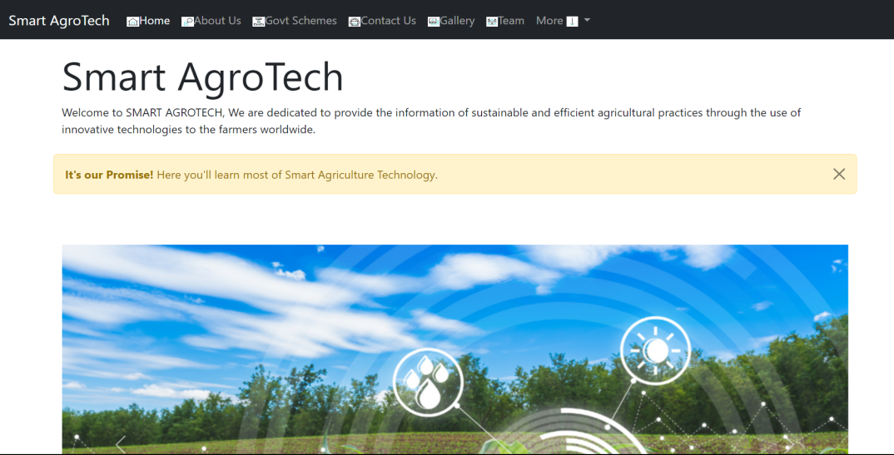

**About Us:** The About Us page provides information about our team and our mission to provide farmers with up-to-date information on smart agriculture technologies. It includes a brief history of our team and a description of our goals.

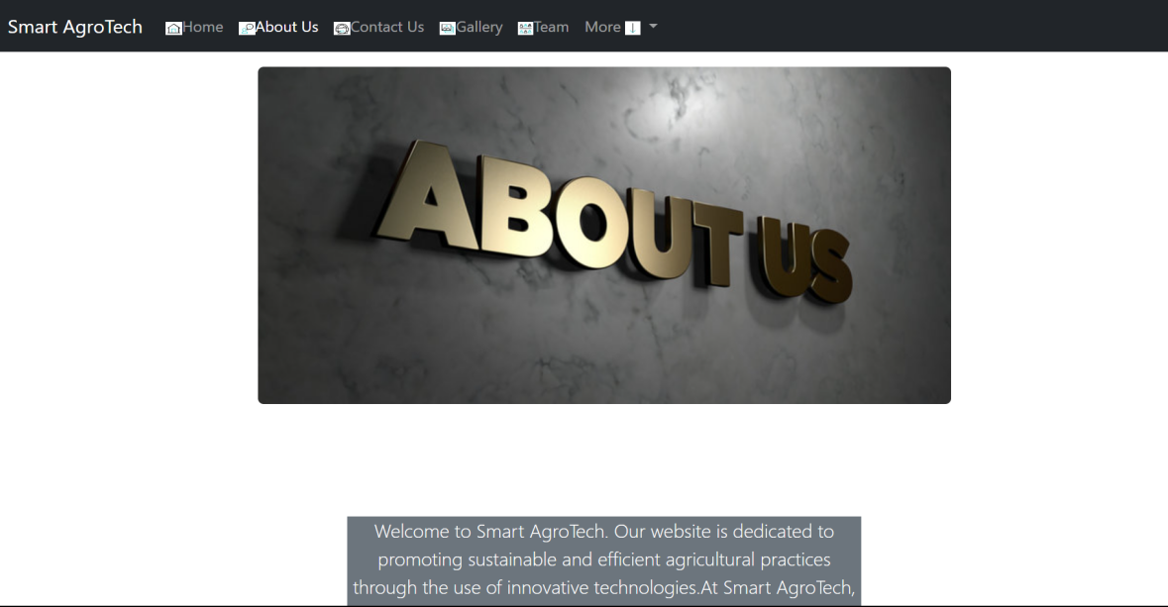

**Government Schemes:** The Government Schemes page provides information on different schemes and programs offered by the government to support farmers. It includes descriptions of different programs and their eligibility criteria, along with links to apply for them.

Ex: Pradhan Mantri Fasal Bima Yojana, Kisan Credit Card Scheme, Soil Health Card Scheme, Pradhan Mantri Krishi Sinchai Yojana, National Agriculture Market Scheme.…

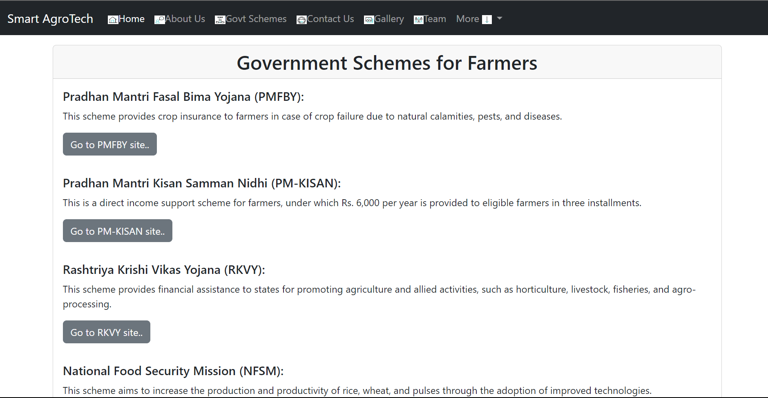

**Contact Us:** The Contact Us page provides users with a form to fill out to get in touch with us. It includes fields for name, email, subject, and message.

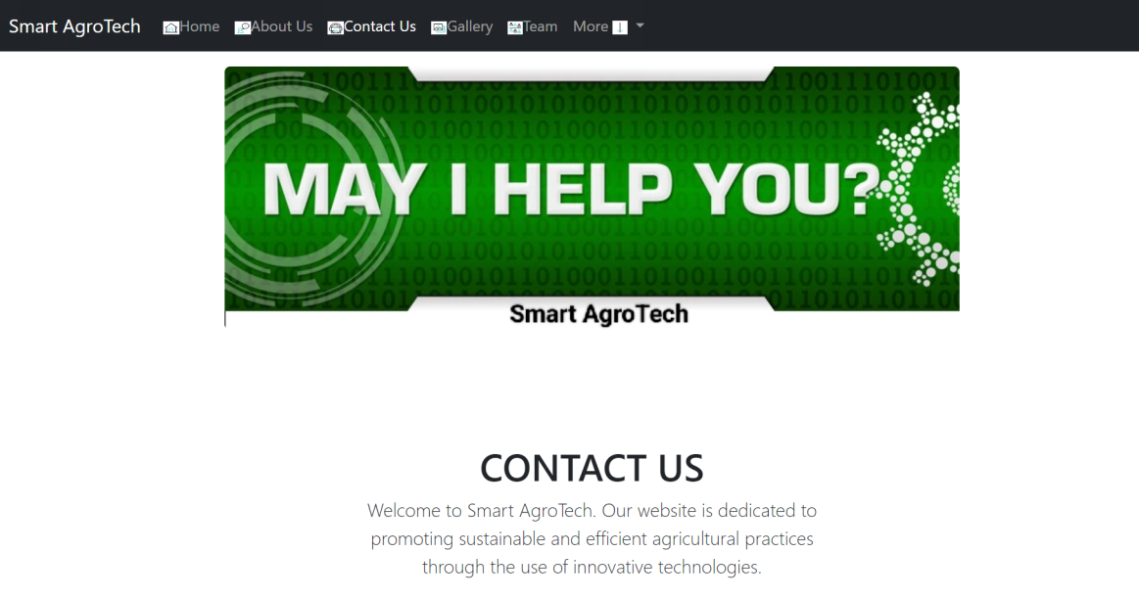

**Gallery:** The Gallery page displays images and videos of different smart agriculture technologies and innovations. Users can browse through different images and videos to learn more about the latest advancements in the field.

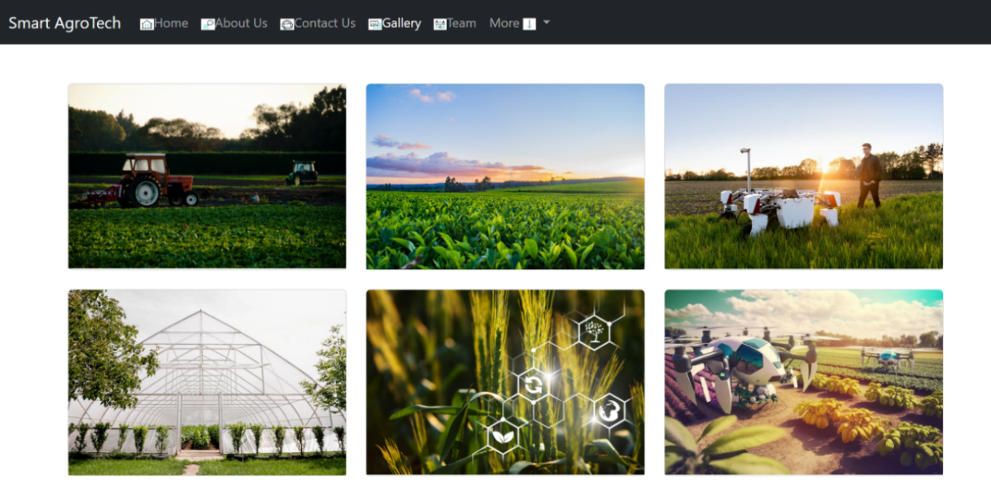

**Team:** The Team page showcases the different members of our team and provides their bios and pictures. This page helps users understand the backgrounds and expertise of our team members.

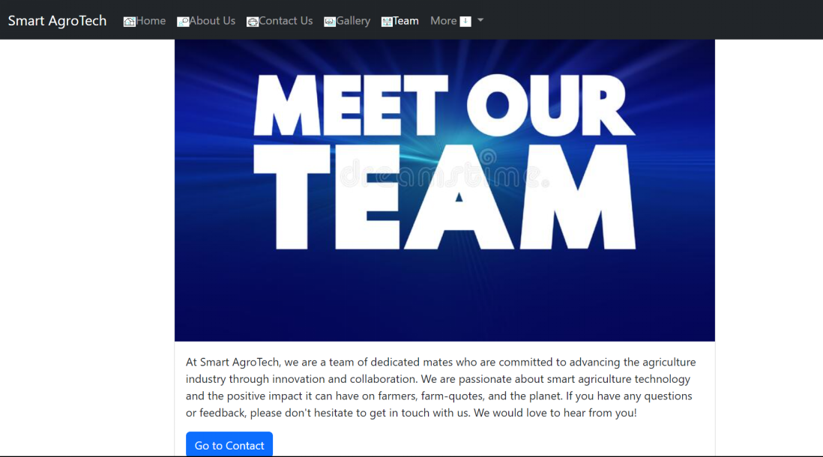

**Precision Farming:** The Precision Farming page provides information about precision farming techniques and technologies. It includes descriptions of different precision farming methods and their benefits, along with images and videos.

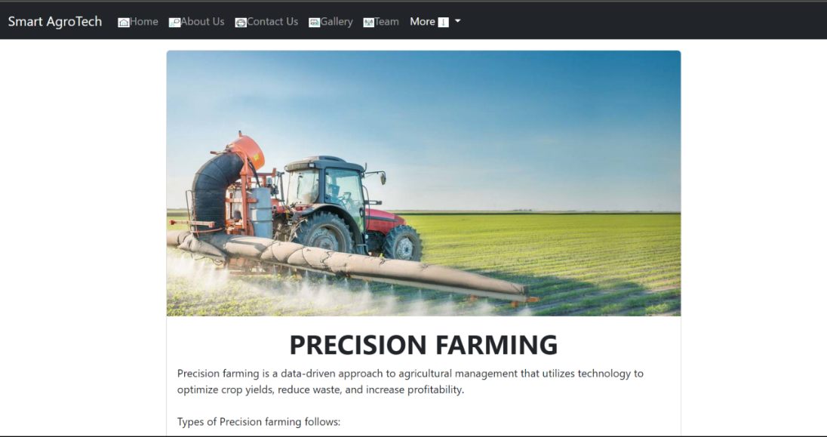

**Automated Machinery:** The Automated Machinery page showcases different automated machinery technologies used in smart agriculture. It includes information on how these machines work and their benefits for farmers.

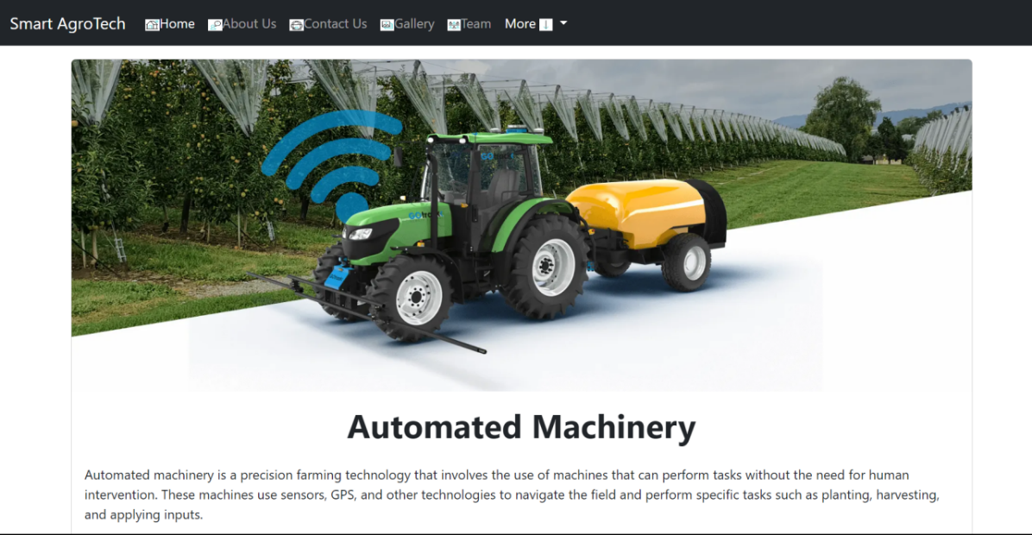

**Vertical Farming:** The Vertical Farming page provides information on the benefits of vertical farming and how it can be used to grow crops in urban environments. It includes images and descriptions of different vertical farming systems.

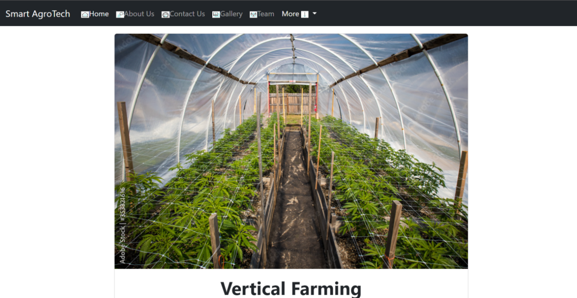

**Crop Management:** The Crop Management page provides information on different crop management techniques and technologies. It includes descriptions of different methods for optimizing crop yield, along with images and videos.

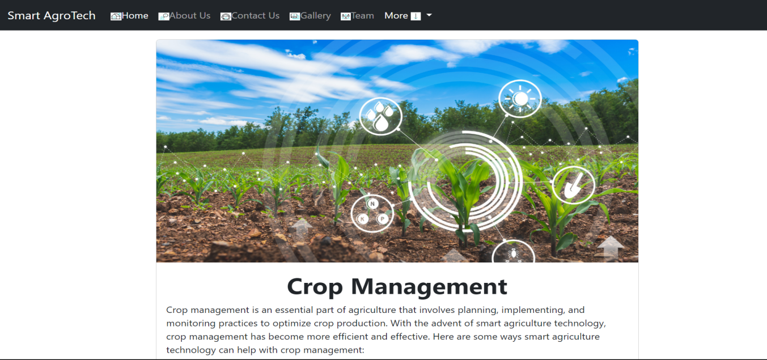

**Livestock Monitoring:** The Livestock Monitoring page provides information on how technology can be used to monitor and manage livestock. It includes descriptions of different livestock monitoring systems and their benefits for farmers.

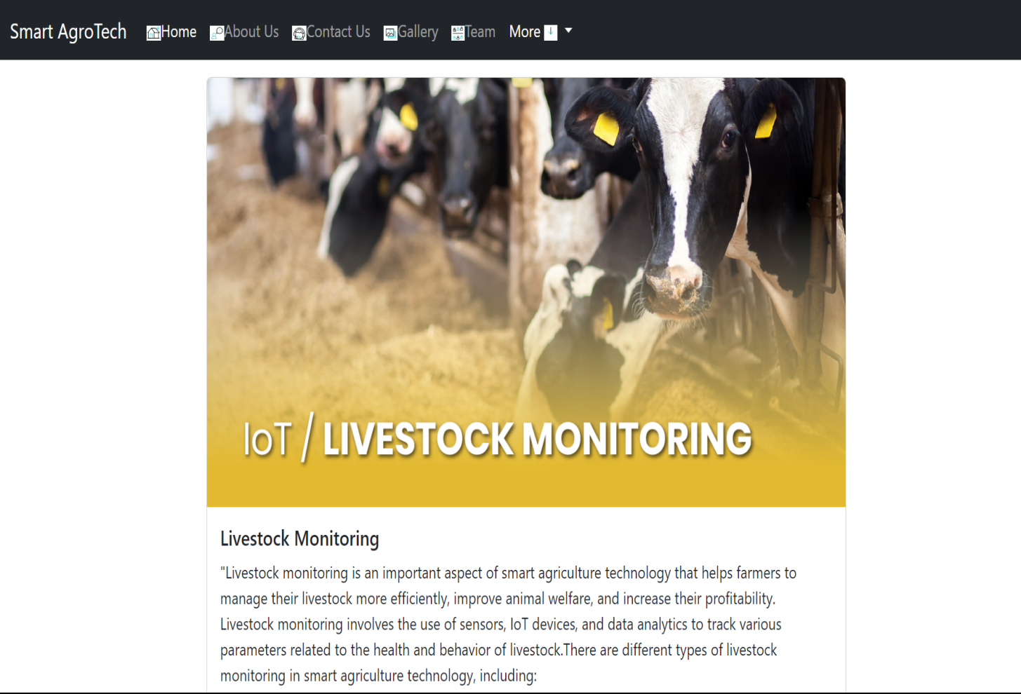

# 

# CHAPTER 8

**RESULTS AND DISCUSSION**

Through the development of the Smart AgroTech website, we were able to create a platform that provides farmers with valuable information on new innovations and smart agriculture technologies. The website has been well-received by farmers and has seen a steady increase in traffic since its launch.

One of the key outcomes of the project was the development of a user-friendly and informative platform that provides farmers with easy access to the latest information on smart agriculture technologies. The website includes a range of features that help farmers stay up-to-date with the latest trends and best practices in agriculture.

Another outcome of the project was the development of a scalable and efficient technical architecture that can handle large volumes of traffic and data. The use of Node.js, Express.js, and MongoDB enabled us to build a platform that can handle thousands of requests per second, while still delivering fast response times and high availability.

Overall, the Smart AgroTech website has the potential to make a significant impact on the agriculture industry, by providing farmers with access to the latest information and technologies. However, there are still opportunities for improvement, such as the integration of additional features and services that can further enhance the value of the platform for farmers.

In future work, we plan to explore these opportunities and continue to improve the Smart Agriculture Technology website, by incorporating feedback from farmers and stakeholders and staying up-to-date with the latest trends and best practices in agriculture technology.

**3.1 Discussion of results**

There are also challenges and limitations to the adoption of digital technologies in agriculture. One of the main challenges is the lack of access to digital infrastructure and resources in rural areas. In order to fully realize the potential of digital technologies in agriculture, it will be necessary to address these infrastructure and resource gaps, and to ensure that all farmers have access to the tools and information they need to succeed.

* Another challenge is the need to ensure that digital technologies are developed in a way that is accessible and useful for all farmers, regardless of their level of technical expertise or resources. This requires a user-centered approach to design and development, which takes into account the specific needs and challenges of farmers, and ensures that the technology is accessible and easy to use.
* Overall, the Smart AgroTech website project has provided valuable insights into the potential and challenges of digital technologies in agriculture. By continuing to develop and improve the platform, and by addressing the challenges and limitations of digital adoption in agriculture, we can help to create a more sustainable and productive future for farmers and the agriculture industry as a whole.

# CHAPTER 9

**References/Bibliography**

* “Innovation in Agriculture: A Guide to Agricultural Technology Innovation and Adoption” by AgFunderNews (https://agfundernews.com/innovation-inagriculture-a- guide-to-agricultural-technology-innovation-and-adoption.html)
* “Digital Agriculture: Opportunities and Challenges for Smallholder Farmers”

by the Food and Agriculture Organization of the United Nations (http://www.fao.org/3/ca2079en/ca2079en.pdf)

* “Precision Agriculture: A Review of Current Trends and Future Directions"

by the Journal of Agricultural and Food Chemistry (https://pubs.acs.org/doi/full/10.1021/acs.jafc.0c05347).